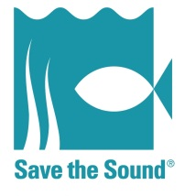
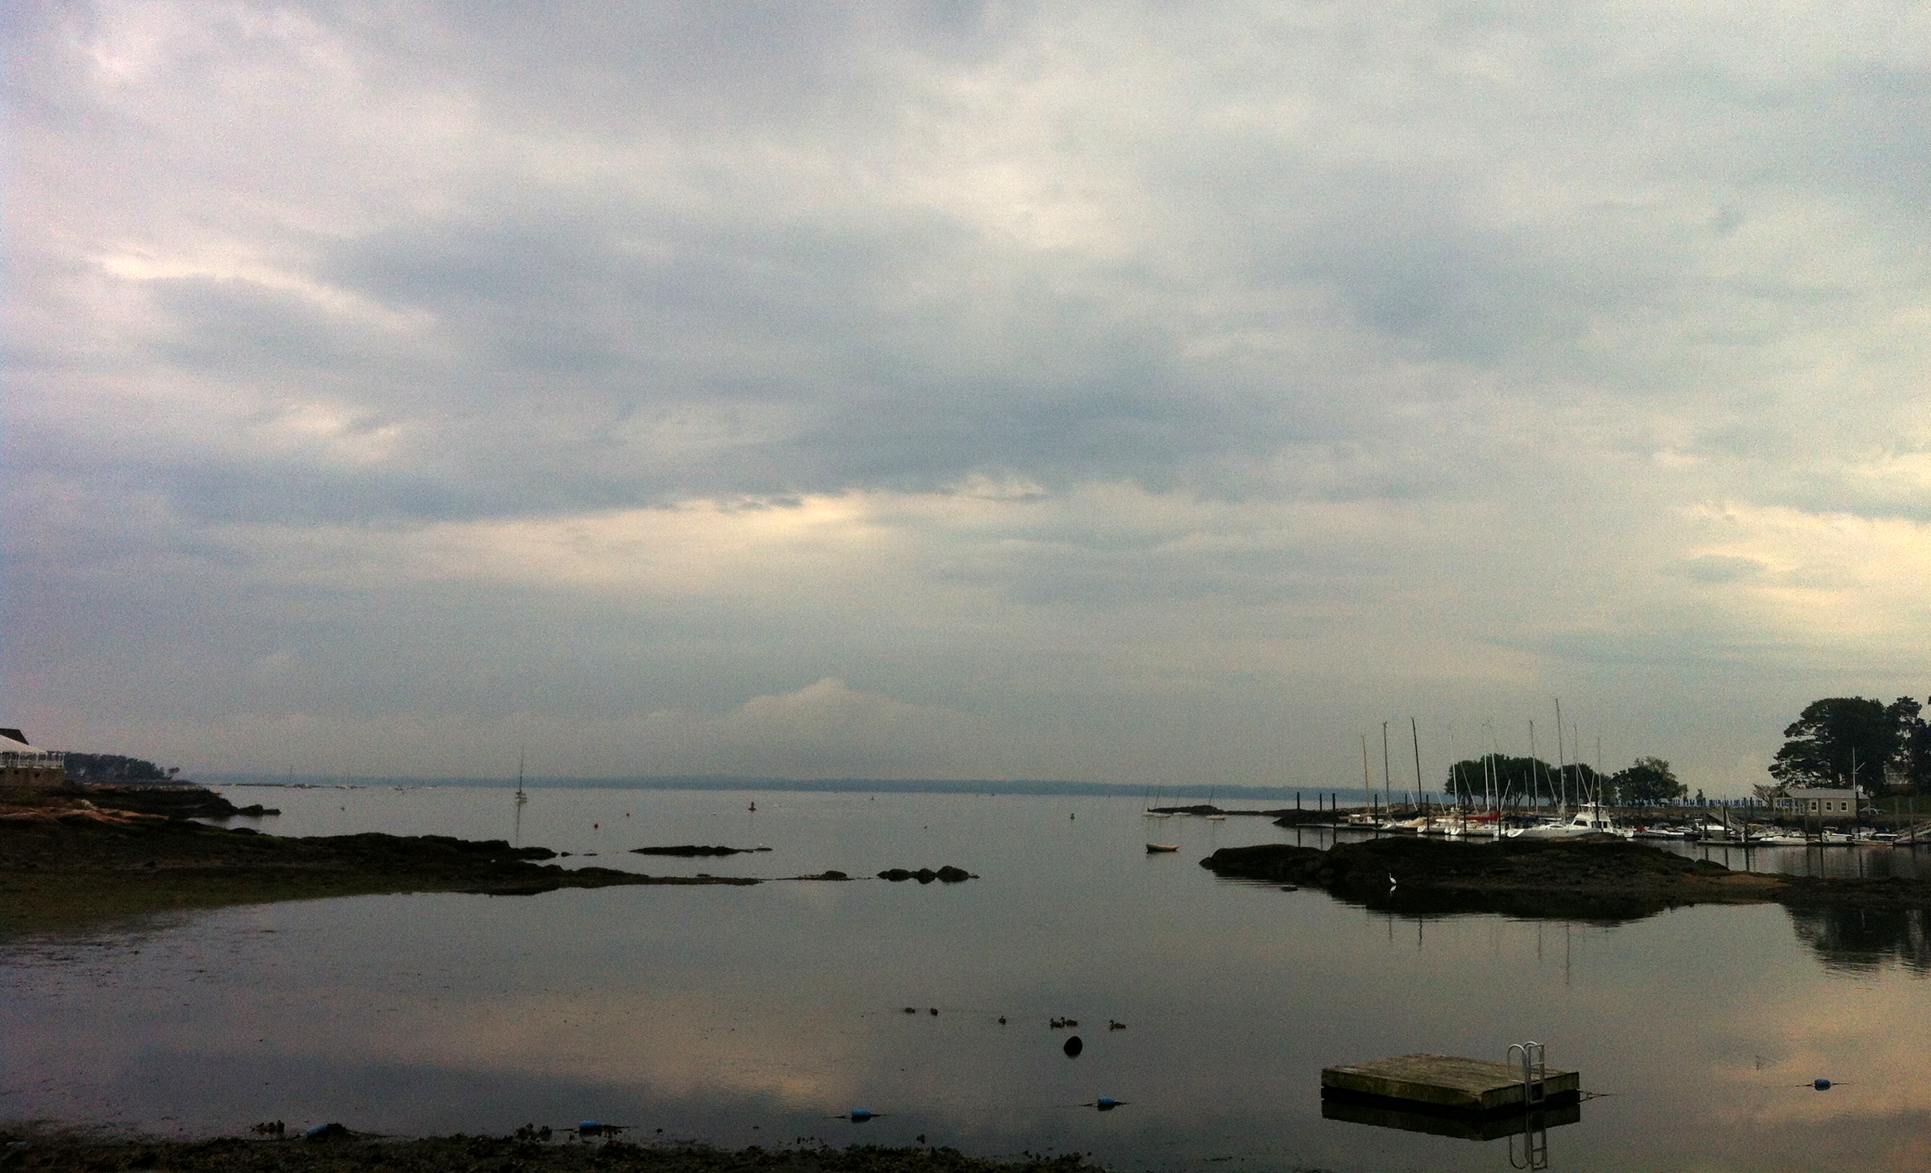
A Safe and Healthy Sound
Water Quality Monitoring 2013

Mamaroneck River, Mamaroneck Harbor,
Beaver Swamp Brook, and Otter Creek

Executive Summary
Every summer Long Island Sound beaches close because bacterial contamination from stormwater, sewer leaks, and other sources is so significant it could endanger the health of the public. In 2012 Westchester County lost 112 beach days from closures and advisories, and in 2013 things got worse: by Save the Sound’s calculations, 138 beach days were lost this past summer.
Residents of the Long Island Sound region should not have to choose between their health and the opportunity to enjoy the beach with their families. This summer—in an ongoing effort to help ensure that Long Island Sound’s waters are safe and healthy for people and wildlife—Save the Sound undertook a pilot water quality sampling project in the Village of Mamaroneck, in cooperation with village officials and local volunteers, to monitor Mamaroneck River, Mamaroneck Harbor, Beaver Swamp Brook/Guion Creek, and Otter Creek.
The goals of the project were:
- to uncover and fix sources of bacterial contamination in local waterways and from storm sewers that were beyond the scope of a previous testing program conducted for the Village by the Arcadis consulting firm;
- to determine locations that warranted additional testing;
- to engage community volunteers;
- to raise general awareness of the problem of bacterial contamination in Mamaroneck and beyond.
Save the Sound received technical and field assistance from staff at Earthplace Harbor Watch. Earthplace is an organization based in Westport, CT; its Harbor Watch program conducts water quality testing in Connecticut and operates a laboratory that is certified for bacteria by the Connecticut Department of Health. Save the Sound was able to use EPA-approved protocols established pursuant to one of Harbor Watch’s Water Quality Assurance Plans.
In Mamaroneck, staff and volunteers took 52 samples from 25 sites on five field visits (June 18, July 2, July 15, July 18, July 22) in Mamaroneck Harbor and along the Mamaroneck River, Beaver Swamp Brook/Guion Creek and Otter Creek.
Sampling locations are shown on the map below. You can view an interactive version, which includes the testing results, by clicking here.
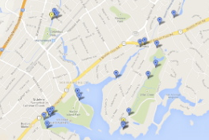
At two sampling sites, on the Mamaroneck River and Otter Creek, bacterial counts grossly exceeded New York State water quality standards. New York State Department of Environmental Conservation water quality criteria state that fecal coliform and E. coli both cannot exceed an average of 200 colony forming units per milliliter (CFU/mL) from five samples.
The results from those sites were promptly presented to Village officials, who identified the responsible landowners as the A&P supermarket on Mamaroneck Avenue and the Mamaroneck Beach and Yacht Club and then worked quickly to rectify the problem.
In addition to those sites, we identified two pollution hotspots that we consider the highest priority for further investigation, with an additional five sites that should be tested further.
Save the Sound hopes to continue and expand water quality testing next summer along the waterways that flow into Mamaroneck Harbor.
What follows is a brief discussion of the results from the four general areas we tested. We recommend that readers refer to the location map and to the attached spreadsheet of locations and data.

Findings at Mamaroneck Harbor (West and East Basins)
Seven outfalls were sampled in the West and East Basins of Mamaroneck Harbor: WB1, WB20, WB2S1, WB30, WB40, MH10, and MH20. All except WB2S1 require a low tide for sampling because the outfalls are in the harbor’s sea wall and are submerged at all but low tides. WB2S1 is a storm drain/grate in the road. These sites were sampled two or three times each.
Sites WB1, WB40, MH10, and MH20 were the only outfalls in this area to have elevated bacterial counts. Their high counts hovered around 1000 CFU/mL for fecal coliform and E.coli, which is above New York State water quality standards. Future sampling should be done to locate those sources of bacteria.
(Note that conductivity/salinity at these sites could be high because of salt water intrusion from the harbor and Long Island Sound. Harbor Watch’s method is to secure samples that represent fresh water values as much as possible, to maximize the likelihood that the samples being tested are the contents of storm drains rather than a mixture of tidal marine water. High salt levels in samples confound the data because the bacteria might be from an unknown source in the harbor or the Sound.)

Findings at Mamaroneck River
Sites MR4, MR5 are outfalls on the Mamaroneck River. MR@4 and MR@St.Pl.Bridge are samples taken from the main stream of the Mamaroneck River.
MR4 was either zero or in the low hundreds of CFU/mL for fecal coliform and E. coli for three repetitive samples, indicating no major contamination and no further testing needed.
MR5 was a major bacterial contamination/grease source from the A&P grocery store on Mamaroneck Avenue. The first sample yielded 5000 fecal coliform and 4000 E. coli and the second yielded 60,000 fecal coliform and 54,000 E. coli CFU/mL. A third sample had so much debris and grease that it clogged the lab equipment. This outfall had very low flow, making its contribution to total bacterial counts significant but not catastrophic. Mamaroneck Village officials quickly brought the problem to the attention of the grocery store’s managers, and the problem has reportedly been fixed.
The Mamaroneck River definitely has additional bacterial sources that have not yet been found. The river from MR@4 was sampled three times. Results for fecal coliform and E. coli ranged from the hundreds to around 5000 CFU/mL (on 7/2/13 at MR@4). That high result probably was due to rain during the previous day or two, as the river had risen and was running much faster.
MR@St.Pl.Bridge, which is downstream of MR@4, was sampled once on 7/15/13 from the Station Plaza Street/Road Bridge, which runs over the Mamaroneck River. This sample was around 1000 CFU/mL of fecal coliform and E. coli; by contrast, samples taken from MR@4 were in the hundreds of CFU/mL on the same day.
The reason for a jump in bacterial counts from one upstream location to a downstream location on the same day could be something as trivial as the difference between sampling the main stream and sampling near a bank, or something as serious as a bacterial source between the sites. The Jefferson Avenue construction project is in between these sites. We did not sample more around this site because of construction barriers.
The Sheldrake River connects to the Mamaroneck River in between MR@4 and MR@St.Pl. Bridge, which further confounds the investigation, as the bacterial source could be upstream on the Sheldrake.

Findings at Beaver Swamp Brook
Sites BSB01 Foot Bridge, BSB@Parkway, BSB@SH, and BSB@Border are all Beaver Swamp Brook main stream sample sites, moving upstream toward the Village of Mamaroneck municipal border. Beaver Swamp Brook drains into Guion Creek, a tidal stream/marsh that empties into Mamaroneck Harbor. Site BSB01 is a 60’’ outfall that technically drains into Guion Creek, near BSBO1 Foot Bridge.
BSB01 was sampled twice at low tide and once at high tide. The low tide samples both had low salinities and high bacterial counts of 1600 and 1560 fecal coliform and 1340 and 1000 E. coli CFU/mL. The high tide sample was contaminated by salt water.
In addition, a strong smell of motor oil or another solvent emanated from the outfall, perhaps from illegal dumping, which warrants further sampling. Because the stream is underground, sampling will require the removal of manhole covers upstream of the storm sewer pipe, using the Village’s engineering drawing of the storm sewer system to pinpoint the correct manholes, or inspection of possible sources above ground.
Main stream sampling of Beaver Swamp Brook on three sampling dates shows a trend of increased bacterial counts from downstream to upstream (sites BSB01 Foot Bridge, BSB@Parkway, BSB@SH, and BSB@Border). There is likely a bacterial source upstream of the Village border (site BSB@Border) because this site consistently had the stream’s highest bacterial counts. Further investigation is warranted beyond the Village border, in Harrison and Rye.

Findings at Otter Creek and Shore Acres Beach
Otter Creek flows through a Nature Conservancy preserve and empties into Mamaroneck Harbor near Shore Acres Beach Club and Mamaroneck Beach and Yacht Club. Shore Acres Beach was shut down more frequently (50 percent of the time) because of bacterial pollution in 2012 than any other beach in the state of New York.
SHB02 is a depression in the mud bank upstream of the Shore Acres Beach and SHB01. This site cannot be seen or accessed except at low tide. At the time of our sampling, liquid bubbled out of the mud intermittently (every few minutes). Two samples were taken on 7/30/13. Both samples were approximately 500,000 CFU/mL for fecal coliform and E. coli, indicating raw sewage (when bacterial counts are that high, accuracy of the count decreases).
The source of this leak was identified as a sewer force main that runs under Otter Creek and connects the Mamaroneck Beach and Yacht Club’s sanitary sewer to the Shore Acres neighborhood system (see the Sanitary Sewer Map of Shore Acres/Otter Creek). Save the Sound brought this finding to the attention of Village officials, who within hours began to work with the Mamaroneck Beach and Yacht Club to fix the faulty sewer. A temporary solution was put into place immediately and a permanent solution is reportedly being planned.
SHB is is the site of a rocky outcrop on Shore Acres Beach. One low tide sample was 19,000 fecal coliform and 15,000 E. coli CFU/mL on 7/18/13; one high tide sample was 600 fecal coliform and 440 E. coli CFU/mL on 7/22/13. SHB01 is a pipe outfall from a sea wall upstream of the Shore Acres Beach, salinity and bacterial counts were low.
Sites sampled on Otter Creek were, in order from upstream to downstream, OCH 955, OC901, OC@Barry, SHB02 (A/B), SHB01, and SHB. Site OCH955 is the “head” of the stream near Soundview Drive. This site had low salinity and relatively low fecal coliform and E. coli counts (200-300 CFU/mL). Site OC901, also behind Soundview Drive, had high salinity and fecal coliform and E. coli counts in the 1,000 range.
Site OC@Barry is located where Barry Avenue crosses Otter Creek. OC@Barry had high salinities and relatively low fecal coliform and E. coli counts. These last two sites are probably heavily affected by the Sound’s tides and only worthwhile for sampling at low tide, if at all.

Conclusion
Our results underscore the need for additional sampling to confirm the locations of high bacterial counts and pinpoint sources. Save the Sound is currently seeking funding to continue and expand water quality testing next summer along the waterways that flow into Mamaroneck Harbor. Particular priority will be placed on confirming that the bacterial leaks from the A&P site and the Mamaroneck Beach and Yacht Club site have been fixed permanently.
Stream sampling on Beaver Swamp Brook upstream and beyond the Village border should also be a priority.
Frequent sampling could narrow down the location of a source by bacterial counts and upstream/downstream logic, even if that source were not an outfall. Outfalls are easy targets, but the sewer leak in the Otter Creek/Shore Acres area shows that sources of bacteria are not always outfalls.
A secondary priority is sampling upstream of BSB01, which will be difficult because it is a buried stream; sampling will require that manholes be opened, with the permission and help of the Village. (Harbor Watch’s protocol for sampling from manholes in the middle of a road is to wear high visibility vests and, if needed, secure the aid of local police to direct traffic for safety.) Upstream conductivity data should be taken because of the motor oil smell, as conductivity data will help track down a solvent/oil source.
Stream walking can also be done on the Sheldrake River and the Mamaroneck River upstream of MR@4, as a follow-up to the testing that Arcadis performed for the village in 2010. Sampling beyond the Village is also an option.
The leak at Shore Acres Beach/Otter Creek was a major find and repairs to the sewer force main are likely to improve the area’s high bacterial count issues. However, there may be other leaks from the same sewer force main or other sewer lines connected to houses, etc.
Lastly, some thoughts on sampling protocol. All good sites should be sampled two or three times before the sampling program moves on to other sites. Repetitive sampling confirms that contamination is an ongoing problem; however, if a sample is raw sewage and an obvious violation, Harbor Watch advises us that one sample is sufficient to require action.
Identifying new sampling sites takes infrastructure/waterway research and field investigations. Local residents and volunteers can be good sources of leads and information about sites worth testing.
Working with the municipality is essential. Local officials hold the maps and infrastructure information that is crucial to any sampling program. For the future, rain gauge data should be obtained from Westchester County Airport or, better, the Mamaroneck Sewage Treatment Plant.
Pending funding, Save the Sound plans to continue and expand water quality testing next summer along the waterways that flow into Mamaroneck Harbor, including the Mamaroneck River, Sheldrake River, Otter Creek, and Beaver Swamp Brook/Guion Creek. Highest priority for testing will be return visits to the A&P and yacht club sites and further investigation at the other two pollution hotspots. Second tier priorities will be the additional five sites with elevated bacterial levels as well as upstream testing on the waterways.

“Beach days” is a measure of the number of beaches closed multiplied by the number of days they were closed. Thus if four beaches are each closed ten times during the year, forty beach days are lost.
Site MR5.
For the purposes of this report, testing sites SHB02A and SHB02B are counted as one site.

